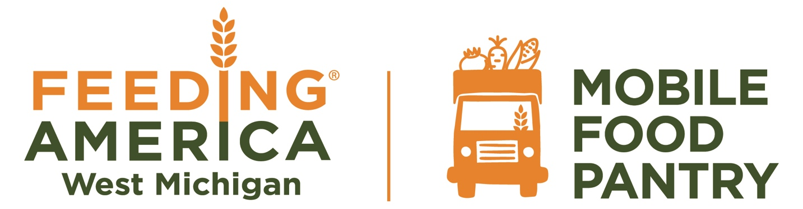

July 11, 2024 | 4:00 PM  Check-in begins
4:30 PM
Distribution begins

First Baptist Church
134 N. Lincoln St
Stanton, MI 48888

For more information call, text or email
Jacky McGill
616-824-3632
jackymcgill@charter.net

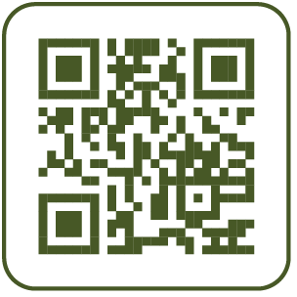
For more information and
food resources near you
visit FeedWM.org
Feeding America West Michigan is a food bank that gathers and distributes millions of meals’ worth of food to nourish neighbors facing hunger in 40 of Michigan’s 83 counties in partnership with hundreds of food pantries and meal programs. This institution is an equal opportunity provider.

